Maps, Flags and Facts
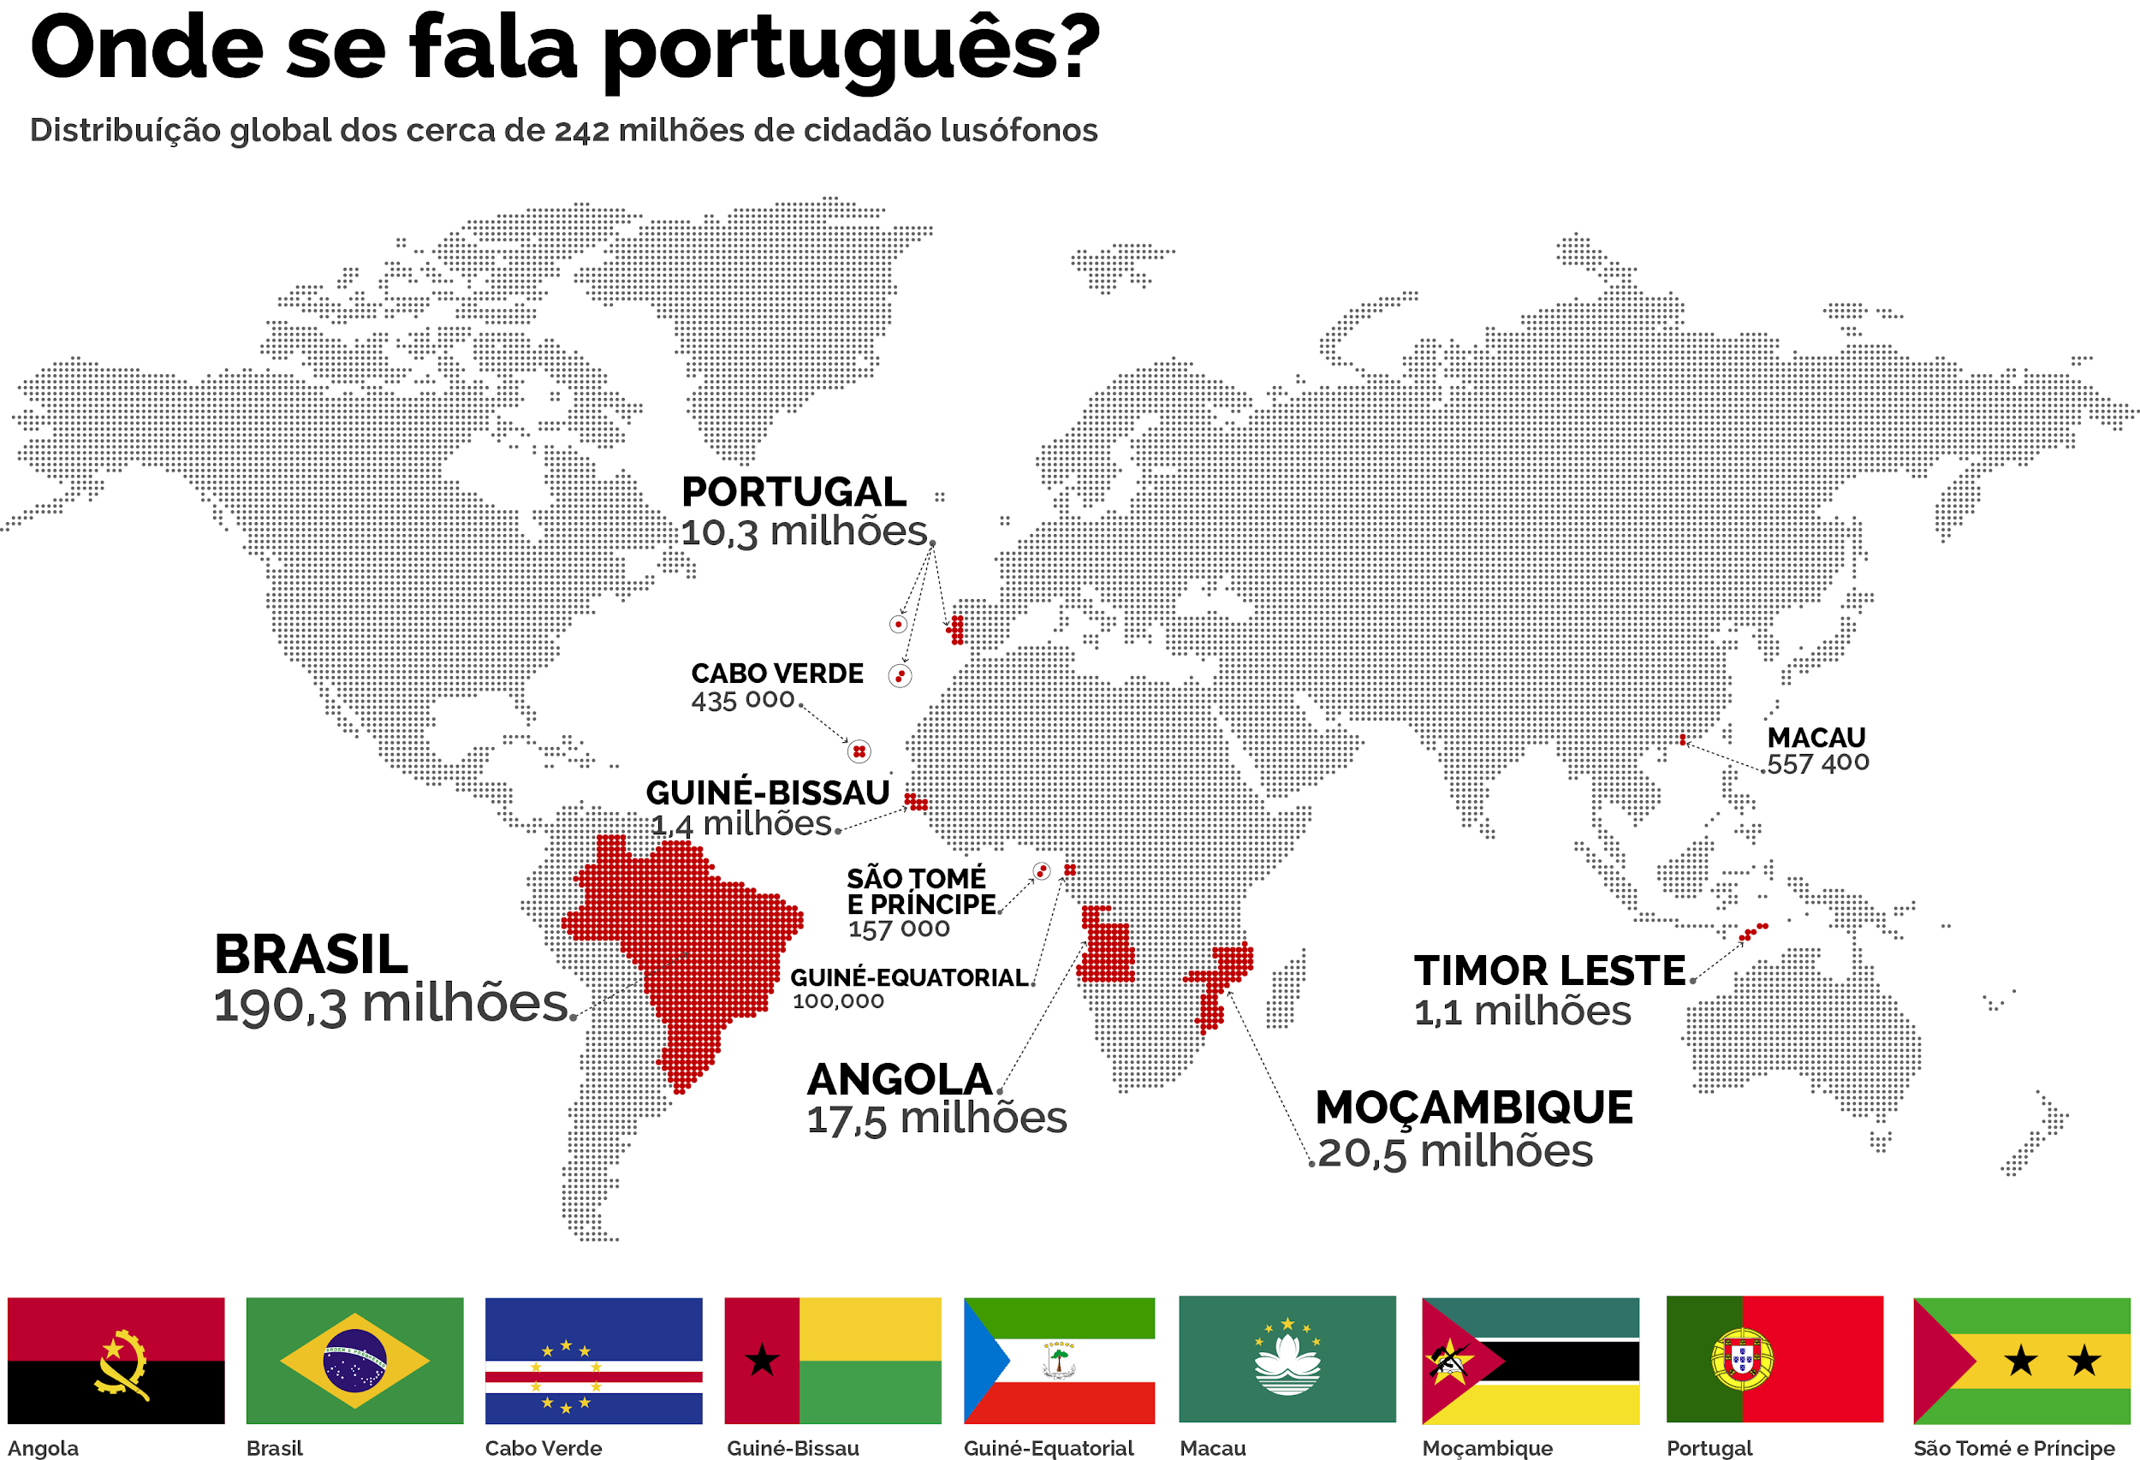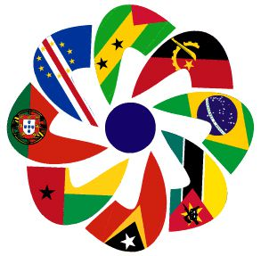

Definitions
Lusophones are a group of peoples and nations across the world that speak the Portuguese language. The Lusofonia, also known as the Lusophone World (Mundo Lusófono), is the corresponding community of Lusophone nations, which exist in Europe, the Americas, Africa, Asia and Oceania. Lusophone nations make up more than 270 million people globally. | CPLP: Comunidade dos Países de Língua Portuguesa  Today, Portuguese-speaking nations of the world have come together for cooperation in politics, culture, and the economy, through the Community of Portuguese Language Nations (CPLP), also known as the Lusophone Commonwealth.

Find out which of the following countries belong to the CPLP. Then match them with their corresponding flag
F G H I J
A B C D E
Timor-leste

1. | 2. | 3.
4. | 5. | 6.
7. | 8. | 9.

CPLP Answers:
Europa: Portugal;
Africa: Angola, Moçambique, Guiné-Bissau, Cabo Verde, São Tomé e Príncipe and Guiné Equatorial;
South America: Brasil;
Asia: Timor-leste (Macau isn’t a country) (Diu, Goa e Damão are cities in India on the Arabic Sea, that made part of the ‘Portuguese India’)

