：



Education 教育Kyoiku

* ***The Japanese education system***

|  |  |
| --- | --- |
|  | The Japanese education system, which includes 9 years of compulsory education in elementary school (Shogakko 小学校) and junior high school（Chuugakko中学校）, is shown in the chart.  Japan has one of the world's best-educated populations, with 100% enrolment in compulsory grades and zero illiteracy. While not compulsory, high school (koukou高校) enrolment is over 96% nationwide and nearly 100% in the cities. High school drop out rate is about 2% and has been increasing.　About 46% of all high school graduates go on to university or junior college. |

* ***Junior High School (Chuugakko中学校)***

|  |
| --- |
| The remaining 3 years of the 9-year compulsory education consist of junior high school education. Most children in the 13-15 age group attend public junior high schools within their district, but some go to private schools. More than 90% of junior high schools are public coeducational institutions. Each year students are assigned to a homeroom with a maximum of 40students (the average class size in 2009 was 33.2), with whom they take their classes. |

* ***High School (Koko 高校)***

|  |  |
| --- | --- |
|  | High school entrance is based on exam performance and the competition is intense for favoured schools. The high school core curriculum includes the following required subjects: Japanese language, geography and history, civics, mathematics, science, health and physical education, art, foreign language, home economics, and information. Extracurricular  activities and integrated study are also required. |

* ***School life (Gakko seikatsu 学校生活)***

In both junior high school and high school, teachers specialise in a particular area. Students put much effort into studying for five regular tests a year and for high school entrance examinations/university entrance examinations, as well as participating in sports or club activities (Bukatsudô　部活動). To learn social-interaction skills, they take part in special events: the cultural festival (Bunkasai 文化祭), sports festival (Taiikusai 体育祭) and the school trip (Shuugaku ryokou 修学旅行).

* ***School uniform (Seifuku 制服)***

|  |  |
| --- | --- |
| Girls wear sailor-collar dresses or blazers; boys wear stiff-collar jackets or blazers.　　These days some schools have more modern uniforms. Summer uniforms are worn from June to September. | [http://t2.gstatic.com/images?q=tbn:ANd9GcSXfMIgyepfd-nYW6eWRiLWsNausCcJUSZJBzVNm3ELgOAlMQp5Zw](http://images.google.com/imgres?q=%E9%AB%98%E6%A0%A1%E7%94%9F%E3%80%80%E5%88%B6%E6%9C%8D&hl=ja&biw=1366&bih=564&gbv=2&tbm=isch&tbnid=OK-2PI0iESsTmM:&imgrefurl=http://yoshie.bz/sampl/person/student/01.html&docid=ZaCmK2y2kqY8mM&imgurl=http://yoshie.bz/sampl/person/student/01.jpg&w=500&h=363&ei=q3uZTqy6HIGWhQfXz9CfBA&zoom=1&iact=rc&dur=920&sig=117316752913385682699&page=2&tbnh=151&tbnw=208&start=29&ndsp=14&ved=1t:429,r:8,s:29&tx=116&ty=74) |

* ***Cleaning (Sōji そうじ)***

Cleaning (Sōji) is a period of about 15 minutes each day when all activities come to a stop, mops and buckets appears and everyone pitches in cleaning up. Often the teachers and principals get on their hands and knees and join students.

Japanese schools don't have any cleaners because the students and staff do all the cleaning. Students in elementary school, junior high school, and high school sweep the hall floors before they go home at the end of the day. They also clean the windows, scrub the toilets and empty the trash cans under the supervision of student leaders.

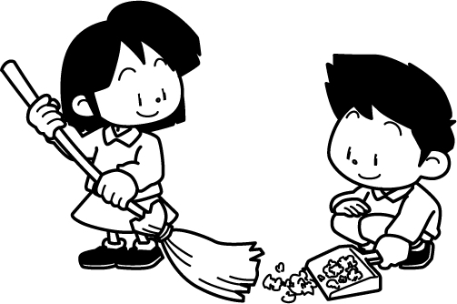



ここで質問！Here is a question.

What do you think about cleaning school by students?

Is it a good idea or not? Write down why you think so?

|  |
| --- |
|  |
|  |
|  |
|  |