私のTY「日本語」シート
Watashi no TY「Nihongo」Sheet

名前 ： _____
^{na ma e}

日
月 日
1 from _ To _
月 日
月 日
2 from _ To _

Day 1 What is Japan like?
日づけ(Date) 月 日

- Make a list of what you know about Japan,
Japanese Culture, and Japanese Language!

- I’m interested in Japanese…..
(ex. Japanese food, Managa, etc )

☆Today’s phrases
↓What is the meaning?

- Se n se i ＿＿＿＿＿＿＿＿＿＿＿
- Ko n ni chi wa! ＿＿＿＿＿＿＿＿＿＿＿
- Wa ta shi wa _______ de su. ＿＿＿＿＿＿＿＿＿＿＿
- Dō zo yo ro shi ku! ＿＿＿＿＿＿＿＿＿＿＿

☆Write about what I discovered or what I found interesting today.

Day 2 What is Japanese like?
日づけ(Date) 月 日

- Make a list of Japanese words you know.

- 4 types of Japanese scripts:

1.
2.
3.
4.
☆Today’s phrases
↓What is the meaning?

- Genki desu ka?
- Genki desu. ＿＿＿＿＿＿＿＿＿＿＿
- Loreto wa big desu. ＿＿＿＿＿＿＿＿＿＿＿
- Japanese wo study shimasu. ＿＿＿＿＿＿＿＿＿＿＿

☆Write about what I discovered or what I found interesting today.

Day 3 Let’s learn Japanese pronunciation!
日づけ(Date) 月 日

- Look at the Romaji table and write down any patterns you
noticed and any sounds that are difficult for you.

- Read the following romaji and
guess the meaning.

- a i ru ra n do
- ba kē sho n
- cho ko rē to
- sa kkā
- kya ra ku tā

☆Today’s phrases
↓What is the meaning?

- Ohayō ＿＿＿＿＿＿＿＿＿＿＿
- Hai / Īe ＿＿＿＿＿＿＿＿＿＿＿
- Arigatō ＿＿＿＿＿＿＿＿＿＿＿
- Sayōnara ＿＿＿＿＿＿＿＿＿＿＿

☆Write about what I discovered or what I found interesting today.

Day 4 Let’s talk about yourself!
日づけ(Date) 月 日

- Make a list of what you like and what you don’t like.

You like you don’t like

- 1.
- 2.
- 3.
- 4.
- 5.

- How to make a verb into a noun

Verb + suru koto

dance suru koto dancing
cook suru koto cooking
(guitar wo) play suru koto playing (guitar)

☆Today’s phrases
↓What is the meaning?

12. Watashi wa ___ ga suki desu. ＿＿＿＿＿＿＿＿＿＿＿
13. ____ga sukijanai desu. ＿＿＿＿＿＿＿＿＿＿＿
- ____ga daisuki desu. ＿＿＿＿＿＿＿＿＿＿＿
15. ____ga kirai desu. ＿＿＿＿＿＿＿＿＿＿＿

☆Write about what I discovered or what I found interesting today.

Day 5 Let’s learn about Japanese school!
日づけ(Date) 月 日

- You will watch 3 videos about Japanese primary school.
Is there any differences between Irish schools and
Japanese schools? Which is better? Why?

The school day

School meals

School events

☆Today’s phrases
↓What is the meaning?

16. itadakimasu. ＿＿＿＿＿＿＿＿＿＿＿
17. gochisōsama. ＿＿＿＿＿＿＿＿＿＿＿
- ____wa ii desu. ＿＿＿＿＿＿＿＿＿＿＿

☆Write about what I discovered or what I found interesting today.

Day 6 Let’s try Origami!
日づけ(Date) 月 日

UU

U

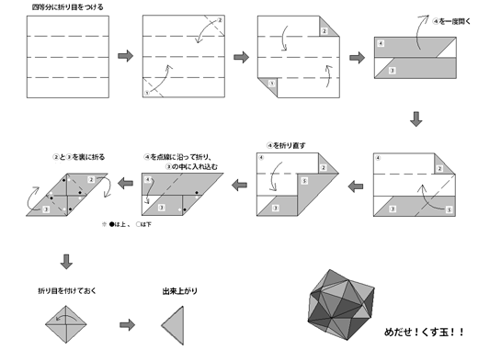

Using 3 Using 6 Using 12
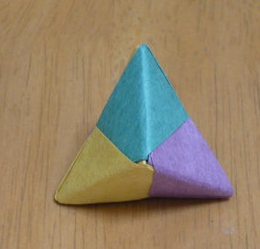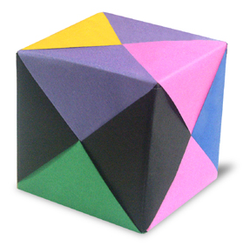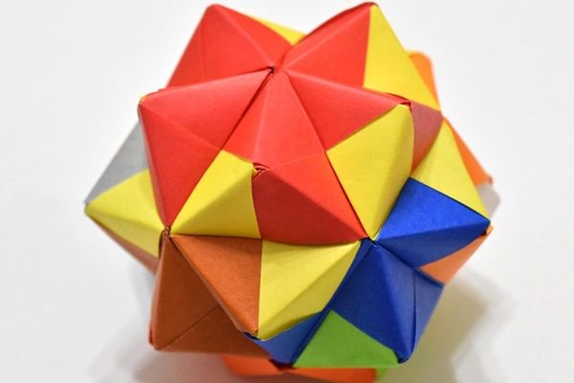

☆Today’s phrases
↓What is the meaning?

19. Kantan desu. ＿＿＿＿＿＿＿＿＿＿＿
20. Kantan janai desu. ＿＿＿＿＿＿＿＿＿＿＿
21. Tanoshii desu. ＿＿＿＿＿＿＿＿＿＿＿

☆Write about what I discovered or what I found interesting today.

Day 7 Let’s count numbers in Japanese!
日づけ(Date) 月 日

16 ・・・ 10 + 6 _____________
_

- 1 ichi 6 roku
2 ni 7 nana/shichi
3 san 8 hachi
4 yon/shi 9 kyū
5 go 10 jū

☆ How do you read the following numbers?

11 ・・・ 10 + 1 ______________

16 ・・・ 10 + 6 ______________

20 ・・・ 2 + 10 ______________

37 ・・・ 3 + 10 + 6 ______________

84 ・・・ 8 + 10 + 4 ______________

☆ What is your favourite number between 1 – 99?

☆Today’s phrases
↓What is the meaning?

22. Today wa ___月___日desu. ＿＿＿＿＿＿＿＿＿＿＿
23. Birthday wa nannandesu ka. ＿＿＿＿＿＿＿＿＿＿＿
24. Birthday wa ___月___日desu. ＿＿＿＿＿＿＿＿＿＿＿

☆Write about what I discovered or what I found interesting today.

Day 7 Let’s see what Japanese food tastes like!
日づけ(Date) 月 日

16 ・・・ 10 + 6 __
_

- Soybean (Soya bean) is important protein in Japanese food.

Food made from soybeans

Tofu
Miso
Nattō
Soy sauce

☆ Traditional Japanese breakfast

Cooked rice
Miso soup
Grilled fish
Egg roll
Stewed dish seasoned with soy sauce and sugar
Vegetables with Japanese dressing
Pickled vegetables
Nori (seasoned seaweed)

☆Today’s phrases
↓What is the meaning?

22. Oishii desu. ＿＿＿＿＿＿＿＿＿＿＿
23. Oishikunai desu. ＿＿＿＿＿＿＿＿＿＿＿
24. _____wo kudasai. ＿＿＿＿＿＿＿＿＿＿＿

☆Write about what I discovered or what I found interesting today.

Day 8 Let’s count people in Japanese!
日づけ(Date) 月 日

16 ・・・ 10 + 6 _____________
_

- 人 = person

1人 hitori 6人 roku nin
2人 futari 7人 shichi nin (nana nin)
3人 san nin 8人 hachi nin
4人 yo nin 9人 kyū nin
5人 go nin 10人 jū nin

☆ Let’s sing a song!

Jūnin no samurai (10 Samurai)

Hitori, futari, san nin iruyo.
Yo nin, go nin, roku nin iruyo.
Shichi nin, hachi nin, kyū nin iruyo.
Jū nin no samurai.

Jū nin, kyū nin, hachi nin iruyo.
Shichi nin, roku nin, go nin iruyo.
Yo nin, san nin, futari iruyo.
Hitori no samurai.

Samurai = samurai warrior

☆Today’s phrases
↓What is the meaning?

25. nan人 kazoku desu ka. ＿＿＿＿＿＿＿＿＿＿＿
26. ___人 kazoku desu. ＿＿＿＿＿＿＿＿＿＿＿
27. (watashi wa) ___sai desu. ＿＿＿＿＿＿＿＿＿＿＿

☆Write about what I discovered or what I found interesting today.

Day 9 Let’s write your name in Katakana!
日づけ(Date) 月 日

ryo リョ

16 ・・・ 10 + 6 _____________
_

- Katakana
a ア | i イ | u ウ | e エ | o オ
ka カ | ki キ | ku ク | ke ケ | ko コ
sa サ | shi シ | su ス | se セ | so ソ
ta タ | chi 千 | tsu ツ | te テ | to ト
na ナ | ni ニ | nu ヌ | ne ネ | no ノ
ha ハ | hi ヒ | fu フ | he ヘ | ho ホ
ma マ | mi ミ | mu ム | me メ | mo モ
ya ヤ |  | yu ユ |  | yo ヨ
ra ラ | ri リ | ru ル | re レ | ro ロ
wa ワ |  |  |  | wo ヲ
n ン |  | *pauseッ | *long vowel ―

ga ガ | gi ギ | gu グ | ge ゲ | go ゴ
za ザ | ji ジ | zu ズ | ze ゼ | zo ゾ
da ダ | di ヂ | du ヅ | de デ | do ド
ba バ | bi ビ | bu ブ | be ベ | bo ボ
pa パ | pi ピ | pu プ | pe ペ | po ポ
kya キャ | kyu キュ | kyo キョ
gya ギャ | gyu ギュ | gyo ギョ
sha シャ | shu シュ | sho ショ
ja ジャ | ju ジュ | jo ジョ
cha チャ | chu チュ | cho チョ
nya ニャ | nyu ニュ | nyo ニョ
hya ヒャ | hyu ヒュ | hyo ヒョ
pya ピャ | pyu ピュ | pyo ピョ
mya ミャ | myuミュ | myo ミョ
rya リャ | ryu リュ | ryo リョ
she シェ | je ジェ | che チェ
ti ティ | di ディ | du デュ
wi ウィ | we ウェ | wo ウォ
fa ファ | fi フィ | fe フェ
fo フォ

☆ Your name in Romaji

☆ Your name in Katakana

☆ Read the following Katakana
↓What is the meaning?
フランス (country) ＿＿＿＿＿＿＿＿＿＿＿
ダブリン (city) ＿＿＿＿＿＿＿＿＿＿＿
ピアノ (instrument) ＿＿＿＿＿＿＿＿＿＿＿
テニス (sports) ＿＿＿＿＿＿＿＿＿＿
ハンバーガー (food) ＿＿＿＿＿＿＿＿＿＿＿
☆Write about what I discovered or what I found interesting today.

Day 10 Where do you want to go?
日づけ(Date) 月 日

y

ryo リョ

16 ・・・ 10 + 6 _____________
_

- These are popular places in Japan for foreigner to visit.
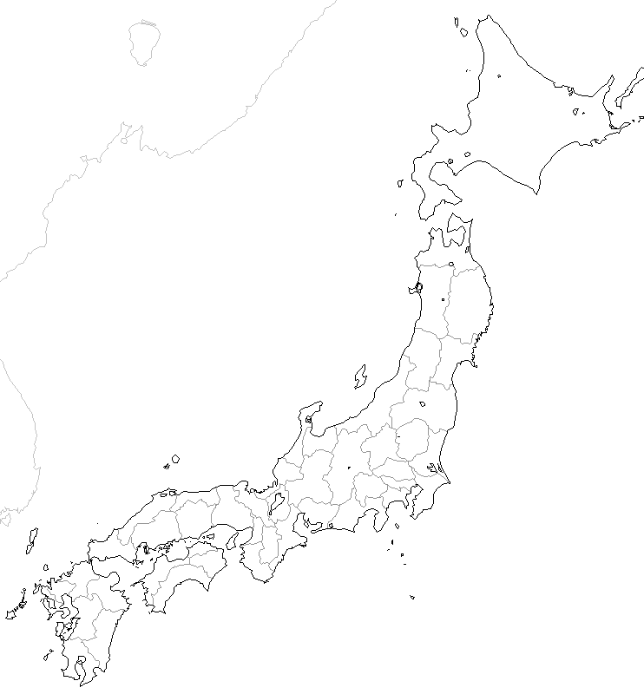
Find out where they are, what attracts people
and where you want to go the most.

      - Niseko
      - Jigokudani monkey park
      - Shirakawa–go
      - Kiyomizu Temple
      - Beppu Onsen
      - Itsukushima Shrine
      - Mt. Fuji
      - Yakushima

☆ Big Upcoming Events in Japan
2019 - World Cup Rugby
2020 – Tokyo Olympic & Paralympic
2025 – Osaka World Expo
☆ Today’s phrases
↓What is the meaning?

25. ___wa omoshirosō desu. ＿＿＿＿＿＿＿＿＿＿＿
26. ___ni ikitai desu. ＿＿＿＿＿＿＿＿＿＿＿

☆Write about what I discovered or what I found interesting today.

Day 11 Let’s write ‘Japan’ in Kanji!
日づけ(Date) 月 日

y

ryo リョ

16 ・・・ 10 + 6 _____________
_

- Japan = 日本 (ni hon)
日 | meaning  sun  day | reading  hi/bi  ni  nichi
本 | meaning  root, origin  main, true,  book | reading  moto  hon
☆ 日本の日 Japanese Day
日本 nihon Japan
の no -'s
日 hi Day

Day 11 Let’s practice self-introduction in Japanese!
日づけ(Date) 月 日

y

There are ___ There are ___people in my family.people in my family.

ryo リョ

16 ・・・ 10 + 6 _____________
_

- We have learned some phrases in Japanese. Try put together and practice your self-introduction.

- Konnichiwa. Hello.

- Watashi wa ______desu. I am _____.

- Birthday wa __ ga tsu ____ nichi desu.
My birthday is ________.

- ____ sai desu. I am __ years old.

- ____ ga suki desu. I like _____.

- ____ ga sukijanai de su. I don’t like _____.

- Dōzo yoroshiku. Nice to meet you.

☆ Today’s phrases
↓What is the meaning?

27. ____ga hoshii desu. ＿＿＿＿＿＿＿＿＿＿＿
28. ____ga tanoshimi desu. ＿＿＿＿＿＿＿＿＿＿＿

☆Write about what I discovered or what I found interesting today.

Day 12 Let’s make a Christmas card!
日づけ(Date) 月 日

y

There are ___ There are ___people in my family.people in my family.

ryo リョ

16 ・・・ 10 + 6 _____________
_

- Make an origami santa face and an origami reindeer.

☆ Today’s phrases
↓What is the meaning?

27. meri kurisumasu. ＿＿＿＿＿＿＿＿＿＿＿
メリー・クリスマス！
28. yoi otoshi wo ＿＿＿＿＿＿＿＿＿＿＿
よいおとしを！

☆Write about what I discovered or what I found interesting today.

Day 12 What are these things?
日づけ(Date) 月 日

y

There are ___ There are ___people in my family.people in my family.

ryo リョ

16 ・・・ 10 + 6 _____________
_

- Washlet

- Purikura

- Kapuseru hoteru

- Yurukyara

☆ Today’s phrases
↓What is the meaning?

33. Kore wa nan desu ka. ＿＿＿＿＿＿＿＿＿＿＿
34. Kore wa English de _____ desu.
＿＿＿＿＿＿＿＿＿＿＿＿＿

☆Write about what I discovered or what I found interesting today.

Day 13 Let’s create Loreto’s mascot!
日づけ(Date) 月 日

y

There are

___ There are ___people in in my family.

rョ

16 ・・・ 10 + 6 _____________
_

- name

- age

- birthday

- likes

- dislikes

- personality

- skills

☆ Today’s phrases
↓What is the meaning?

33. _____ ga dekimasu. ＿＿＿＿＿＿＿＿＿＿＿
34. _____ga dekimasen. ＿＿＿＿＿＿＿＿＿＿＿

☆Write about what I discovered or what I found interesting today.

Day 14 Lets write your New Year’s resolution in Japanese !
日づけ(Date) 月 日

y

There are ___ There are ___people in my family.people in my family.

ryo リョ

16 ・・・ 10 + 6 _____________
_

- Write down what you hear in Romaji.

__ __ __ __ __ __ __ __ __ __ __ __ __ __.

__ __ __ __ __ __ __ __ __ __ __ __ __ __ __.

- Write down your New Year’s resolution in English.

- Write down your New Year’s resolution in Japanese.

☆ Today’s phrases
↓What is the meaning?

29. akemashite omedetō (gozaimasu). ＿＿＿＿＿＿＿＿＿＿＿
30. kotoshimo yoroshiku (onegaishimasu).
＿＿＿＿＿＿＿＿＿＿＿＿＿＿＿＿＿＿＿＿＿＿＿

☆Write about what I discovered or what I found interesting today.

Day 15 Lets play Hiragana bingo !
日づけ(Date) 月 日

y

There are ___ There are ___people in my family.people in my family.

ryo リョ

16 ・・・ 10 + 6 _____________
_

- Write down any Hiragana you like below.

☆ Today’s phrases
↓What is the meaning?

31. sumimasen. ＿＿＿＿＿＿＿＿＿＿＿
32. moikkai itte kudasai. ＿＿＿＿＿＿＿＿＿＿＿

☆Write about what I discovered or what I found interesting today.

Day 17 Let’s play ‘Fukuwarai’!
日づけ(Date) 月 日

y

There are ___ There are ___people in my family.people in my family.

ryo リョ

16 ・・・ 10 + 6 _____________
_

- mayuge

- me

- hana

- kuchi
u e

mi gi
hi da ri

shi ta
☆ Today’s phrases
↓What is the meaning?

33. mō choto ＿＿＿＿＿＿＿＿＿＿＿
34. motto ＿＿＿＿＿＿＿＿＿＿＿

☆Write about what I discovered or what I found interesting today.

Day 19 Let’s write ‘Japan’ in Kanji!
- Japan = 日本 (ni hon) Japanese
- = 日本 (ni hon)

ryo リョ

16 ・・・ 10 + 6 _____________
_
- Japan = 日本 (ni hon)
- Japanese (people) = 日本人 (ni hon jin)
- Japanese (language) = 日本ご (ni hon go)
日 | meaning  sun  day | reading  hi/bi  ni  nichi
本 | meaning  root, origin  main, true,  book | reading  moto  hon
At the end of the TY Japanese course…

☆ Now I know about Japan and Japanese Culture!

- Now I can do it in Japanese!

☆ I want to know more about…….

