Pedagogical Manual : MFL Department

Section | Teaching and Learning
Resource | TL1: Responding to and managing change
Objective | To assess and mitigate the potential impacts of change and how to plan to move beyond them.
Outcomes | - To consider and reflect on the change curve  - To use Leavitt’s Diamond to assess the four components of your MFL team  - To introduce a change to the components of the MFL team, to assess the impact that this will have and your next steps as a department.
Resources | TL1 Leavitt’s Diamond
Time | 35-40 minutes

Rationale
Change in education is a common challenge for all teachers. Managing that change is often a burden felt by teachers individually. However, an MFL department can help break apart that burden into smaller parts that can be approached by individual members thus reducing stress and the feeling of isolation.

Part 1: Reflection of change | 5 mins | Display the following diagram, The Change Curve, so that your MFL team can see it. As a group, think about a change in education that has taken place at a local or national level that has affected you in the past and consider each of the phases underneath.  Reflect on particularly how you survived the change in the rebuilding phase and what this looked like.  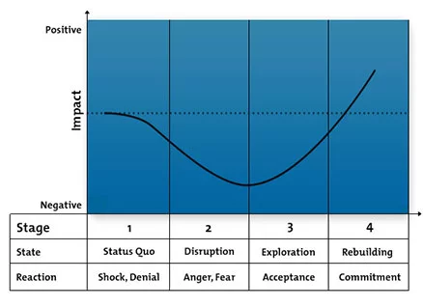
Part 2: Leavitt's Diamond | 5 mins | At this stage, you are going to use Leavitt's Diamond to assess the way in which change will affect or has affected your team.  Leavitt’s Diamond posits that an organization has four major components that are all interdependent:  - Tasks  - People  - Structure  - Technology  According to this approach, before you bring about change or are forced to respond to change in any one of the four components, you should evaluate the impact on the other three components.  To implement change successfully, you need to find the right balance between all of them or predict the ways in which change is going to affect these elements.  Firstly, take the resource attached to this sheet and as a group consider the questions around the edge to understand the characteristics of each of the components that affect your team.
Part 3: Introducing Change | 10 mins | On the reverse of the Diamond you will find a blank diamond. This is for you to troubleshoot the impact of change.  At the top of the sheet describe the nature of the change.  Then circle the component that this is going to affect.  Next, write down two ways in which this change is going to affect the other three components. It is important to think about how this change is going to affect you not just in the short term, but also the medium and long term.

Part 4: Responding to change | 15 mins | Consider as a team each of the impacts individually.  What will your response as a team to each of the impacts? This should be an action-oriented approach. For example, if the change requires the introduction of a piece of technology, you might suggest:  - Person X does the training online  - Person Y will download the software to our laptops  - Person Z will organise a meeting where we will deliver the training  Although this approach does not necessarily resolve potentially bad change, it helps you to mitigate the effects of the change and prepare your team so that the impact is as minimal as possible.

Pedagogical Manual : MFL Department
TL 1: Leavitt’s Diamond

What are the responsibilities of staff in your department?

Who is responsible for the department above in the management structure? What is their role?

How do you bring tasks to fruition (work flow)?

What is the communication flow?

What are the expectations of staff in your department?

How do staff get work done?

Why does the department exist?
What technology do we use?

What training do we have?

What are the beliefs, attitudes and behaviours of your department?

What are your skill levels?

What are you trained to do?

What are the rewards that motivate you?

What is your work culture?

The change affecting our team is:

Circle the component that this relates to:
STRUCTURE PEOPLE
TASKS TECHNOLOGY

Impact 1:
Impact 2:

Impact 1:
Impact 2:

Impact 1:
Impact 2:

Impact 1:
Impact 2:

