**Spirited Away Worksheet**

**Background Information**

***Spirited Away*** is an (1) __________ film which was written and directed by _________________. It’s Japanese title is _______________________. It is one of a series of films produced by __________________. It has won many film awards including an ______________ for Best Animated Film. The Director has made many famous films including (i)_______________, (ii) ________________ and (iii)_______________________.

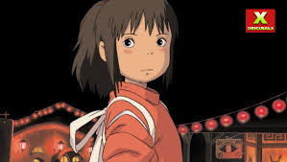

What rating is this film given on the film ratings website “**Rotten Tomatoes**”? _________________________________________________________

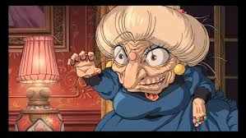

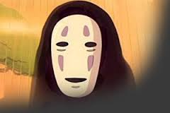

**Story Outline**

The story centres around a 10 year old girl called _____________. The girl and her parents find themselves trapped in a ____________ world which is ruled by a greedy witch called __________. Her parents are turned into ___________, and it is up to ________to find a way for her parents and herself to return to their normal world. A mysterious boy named _________ comes to her aide and helps her to remain safely in the spirit world. The girl takes a job in a _____________where she meets many strange characters including (i) _____________, (ii) ___________ and (iii) _____________.

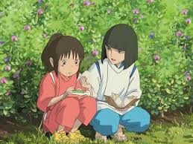

**Answer while watching the film.**

|  |  |
| --- | --- |
| |  | | --- | | **1.** **Chihiro was afraid of moving to her new house and school.** |   True False |
| |  | | --- | | **2.** **What kind of spirit is Haku?** |   Bloody Killer Spirit Tree Spirit  Nice Giver Spirit Kohaku River Spirit |
| |  | | --- | | **3.** **Zeniba offered dinner to Sen, No-face, Baby, and the little bird.** |   True False |
| |  | | --- | | **4.** **Yubaba succeeded in destroying No-Face.** |   True False |
|  |
| |  | | --- | | **5.** **No-Face wanted to stay with Zeniba and help her.** |   True False |
| |  | | --- | | **6.** **Baby was turned into what kind of animal?** |   cat mouse guinea pig dog |
| |  | | --- | | **7.** **The Radish Spirit tried eating Sen.** |   True False |
| |  | | --- | | **8.** **Who ate the medicine cake?** |   Sen, Lin, and Yubaba Sen, No-face, and Lin  Sen, No-face, and Zeniba Sen, No-face, and Haku |

