Trip to Japan Project
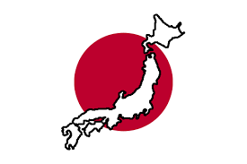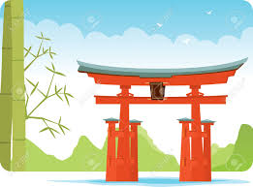

Group Name: Member’s Names：

Task: You are planning an imaginary trip to Japan. In groups, use the suggested websites below to come up with an itinerary, suitable accommodation, travel arrangements, a budget, etc.

Cover the following points in your research and presentation:
- Where will you go?

- When, what season?

- Budget? Approximately how much you will spend?

- What kind of transportation will you use?
Fly into Narita (Tokyo Intl Airport) or Kansai Airport, use the Bullet Train, etc.

- Where will you stay? How long?

- Why have you chosen these place(s) to visit?

- What will you do?
i.e. Sight seeing, eating, watching sumo, shopping, going to concerts…etc.

- What sources did you use?

Using the information you have gathered in your research, create a short presentation on your planned trip. Demonstrate how the work load has been shared amongst your group members.

Date of presentation will be in class in December
Duration of each group: 3~5 minutes
All students submit worksheets to me in advance of your presentation.

Tips…
Include some aspect of Japanese culture, i.e. onsen (hot springs), types of food, shopping (Harajuku for fashion, Akihabara for electronics), festivals, famous shrines/temples, etc.
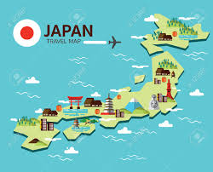

General information on Japanese culture and travel guide can be found in the following sites:
http://www.japan-guide.com/
http://web-japan.org/kidsweb/
http://www.jnto.go.jp/eng/arrange/transportation/index.html
http://www.lonelyplanet.com/japan?intaffil=bbctrv-e
http://gojapan.about.com/
http://www.japaneselifestyle.com.au/travel/traveltojapan.html

Group Task Allocation – who will do what?

