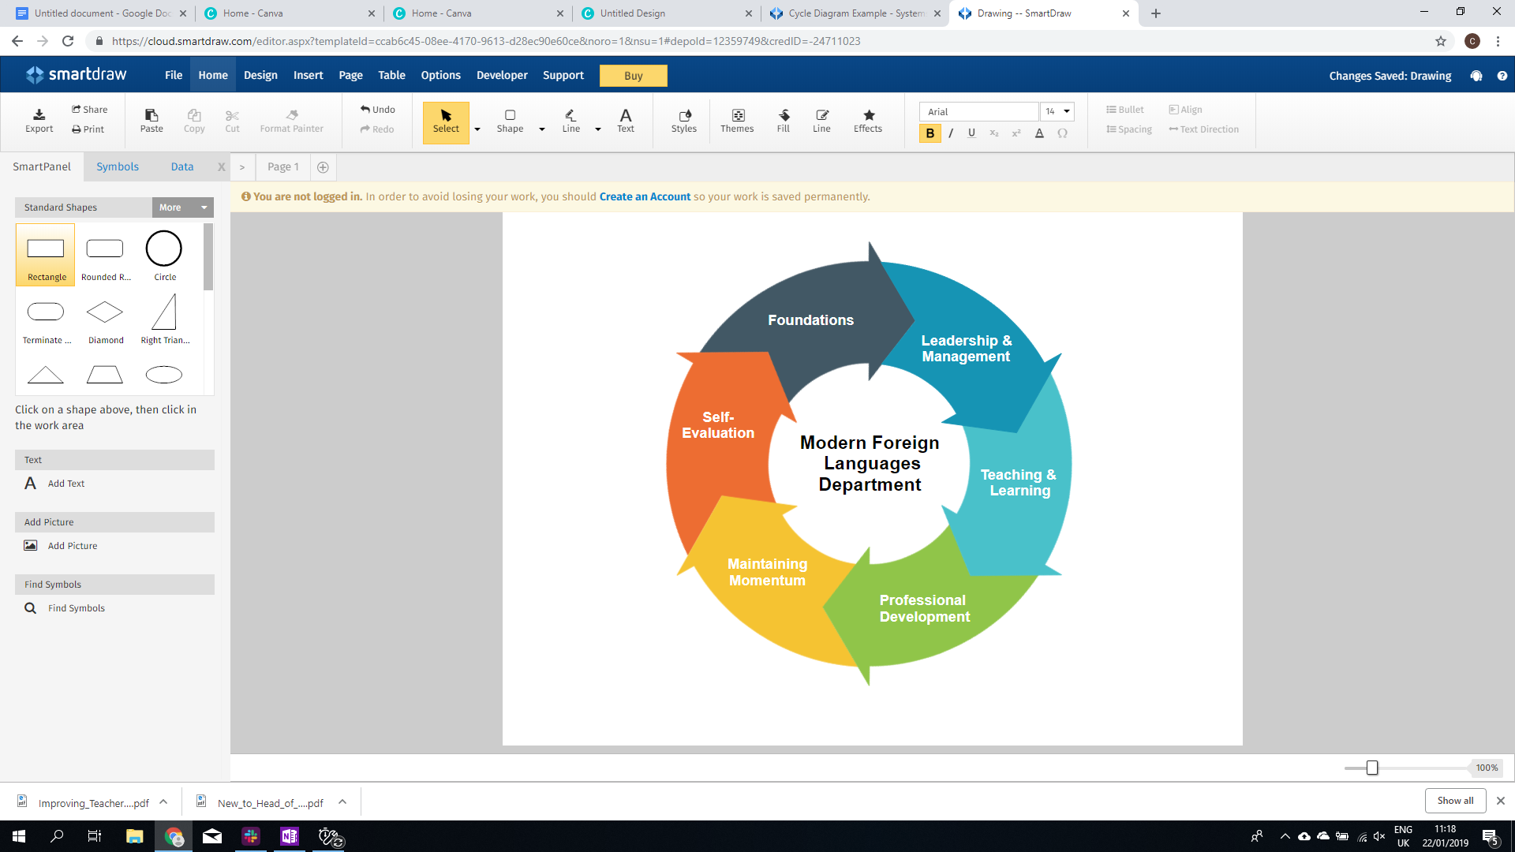

**Pedagogical Manual :** MFL Department

|  |  |
| --- | --- |
| **Section** | **Leadership & Management** |
| **Resource** | LM4: Creating a communication policy. |
| **Objective** | *To create your team’s communication policy to enable you to work effectively as a team.* |
| **Outcomes** | * To brainstorm what good communication looks like * To outline where face-to-face communication should occur * To define your outward communication to stakeholders * To outline the aspects of good practice email etiquette |
| **Resources** |  |
| **Time** | 30 mins |



|  |  |  |  |
| --- | --- | --- | --- |
| **Part 1: Good and Bad Communication** | 5 mins | As a team, watch the following [video](https://www.youtube.com/watch?v=Wz7qZDaf9a8) about good and bad communication.  Briefly reflect on examples in your professional or personal lives of where communication has been good and where it has been a challenge.  When answering the following questions, brainstorm a couple of adjectives/feelings regarding how you feel. Write them on a whiteboard of piece of paper so everyone can read them:   1. *How does good communication make you feel?* 2. *How does bad communication make you feel?* | |
| **Part 2: Communication within the team** |  | **Email etiquette and Face-to-face communication**  Email is often the most suitable system to use for internal communication; however, it is important to establish a few rules regarding email etiquette. Here are some examples.   1. Make sure your message is simple and clear 2. Use good spelling, punctuation and grammar 3. Respond to emails in a timely manner - agree a time frame 4. Make emails action-orientated 5. Beware of ‘reply all’ button 6. Make the subject line grabbing 7. Know your audience 8. Don’t hide behind your email 9. Establish rules of when email will be consulted 10. Review emails before you send them.   Based on these rules of email etiquette, try to create your own 10 rules that you will follow and display these on your notice board or print off copies for members of staff to keep in their teaching files. | |
| **Part 3: External Communication** |  | External communication is also essential for the identity of your department and what it represents in the eyes of others.  Firstly, brainstorm all of the stakeholders who are external to your team e.g. principal, parents, students...  Secondly, decide what ways and means there are to communicate with these stakeholders e.g. social media, newsletter…  External communication can be job in itself so it is advisable that you just choose one line of communication to begin with. Once chosen decide   1. Your audience 2. Its purpose/content e.g. assessment, extracurricular resources 3. Its length 4. Rotation of responsibility 5. Its frequency   Put this date into your calendars/diaries so that people are aware of the responsibilities and publish on your notice board. | |