Pedagogical Manual : MFL Department

Section | Leadership & Management
Resource | LM3: Creating and managing a shared virtual workspace
Objective | To create your own shared workspace within a virtual environment that all departmental members can contribute to.
Outcomes | - To follow the principles outlined in this guide to create your virtual learning environment.
Resources | Virtual workspace good principles
Time | Ongoing

Rationale
Having a shared workspace is essential for the effective leadership and management of the team especially if you are working collectively. In many schools, a physical space is not possible; however, a virtual space is way that you can overcome this. In addition, it also means that access to the space can be undertaken without the restrictions of a physical space thus making your team more productive.

Part 1: Cloud-based storage | When we refer to things being ‘in the cloud’, this means that any computer file that we interact with on our computers is not stored physically on the computer we are using. In a cloud-based system, the file is stored securely on another computer/server somewhere else in the world. The advantage of this system is that you can access the file anywhere in the world without the need to use the same computer or even the same device (e.g. on phone or tablet).  There are many cloudbased storage systems available and your school probably has access to one (e.g. Google Drive, Office365, Dropbox). It is advisable that you use the same one as your school, particularly if student email addresses are held within the same system.  Actions:  - Familiarise yourself with the system that your school has  - Look at ways that colleagues use the Cloud-based environment in their subject areas.  - Try to start to use the cloud-based approach for all your own files by transferring some of them to the cloud-based system.
Part 2: Good practice of virtual workspace. | A virtual workspace should be thought of like a physical workspace. If it is messy, cluttered and in general disorder this then becomes a difficult environment to work in.  If all papers, folders and resources are stored in filing cabinets, on shelves or in drawers, then these resources can be retrieved easily by any member of the team when necessary and returned without fuss.  A virtual workspace follows the same principles. Below are a number of principals that you should adhere to as a team to ensure that you maintain a pleasant working environment for everyone.

Pedagogical Manual : MFL Department
LM3: Creating and managing a shared virtual workspace

- Everyone must have equal access to the virtual learning environment. On some platforms (such as Google Drive) users can have their own private area as well as a Team Drive. A helpful video can be accessed here

- Everyone should make a commitment to store their documents on their shared drive to be used collaboratively. Only personal material should be kept in your own area.

- Design a Virtual Workspace architecture. This refers to the folder structure that you will use. The diagram below gives a very simple outline of the folder structure you might choose to create.

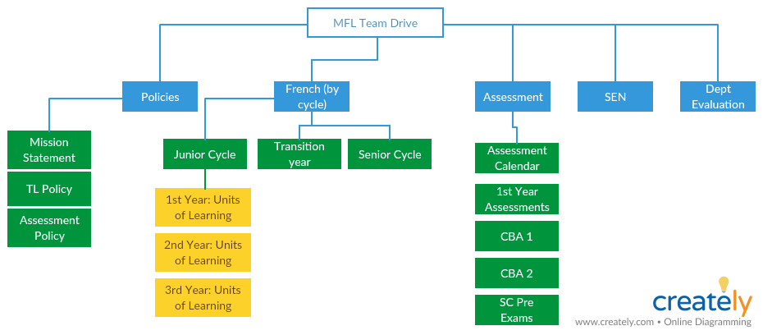

4) Take time to begin sorting resources. Transfer and upload sources from your personal devices to the shared area so that everyone can collaborate.

5) Only save quality resources. Very quickly, your drive can clog with lots of repeated documents or documents of poor quality. In order to avoid issues of sifting through lots of resources, only upload documents that you believe are worthwhile.

6) Make sure that you make your documents editable or not. If you want them to be fixed and uneditable then either save them as PDFs or change the sharing settings. There are many websites that can do this for you if you search ‘convert to PDF’ in your browser.

