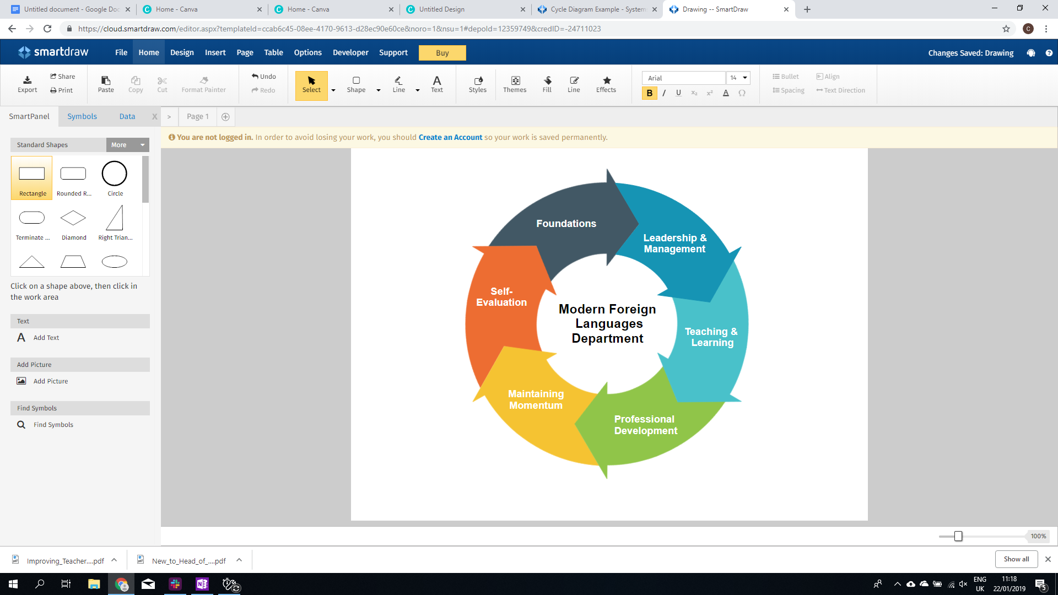

**Pedagogical Manual :** MFL Department

|  |  |
| --- | --- |
| **Section** | **Leadership & Management** |
| **Resource** | LM2: Setting targets based on your School Self Evaluation. |
| **Objective** | *To create departmental targets that enact whole-school targets but in the context of the language learning classroom in your school.* |
| **Outcomes** | * To understand the role your department plays in your school SSE * To translate the target domain into visible practice in the classroom * To evaluate your effectiveness as a department in the chosen domain * To suggest potential list of actions |
| **Resources** | [School Self-Evaluation Document](https://www.education.ie/en/Publications/Inspection-Reports-Publications/Evaluation-Reports-Guidelines/School-Self-Evaluation-Guidelines-2016-2020-Post-Primary.pdf) from DES  Statements of effectiveness from above document  A3 paper and glue |
| **Time** | 40 minutes |



|  |  |  |
| --- | --- | --- |
| ***Part 1: School Self Evaluation*** | Pre-  Session | A member of the team should find a copy of the SSE for your school and find out what the ‘domain of focus’ is for the current academic year. According to the *School* [*Self-Evaluation Guidelines*](https://www.education.ie/en/Publications/Inspection-Reports-Publications/Evaluation-Reports-Guidelines/School-Self-Evaluation-Guidelines-2016-2020-Post-Primary.pdf)*,* this could be one of the 8 domains found in the document on page 17 and the accompanying statements of effective practice on page 23 onwards that correspond with the domain.  The Statements of Effective practice should be photocopied and cut up into individual strips so that the statements of effective practice can be considered individually. |

|  |  |  |
| --- | --- | --- |
| **Part 2: Effectiveness** | 5 mins | Elect a facilitator for this meeting who will run the discussion.  First, go round the group and finish the following sentence with a number of different statements.  **“I am an effective teacher because…”**  **Being effective is an important adjective in education. It describes how anyone involved in the education of a child or adult is able to effect positive change. This could be helping them to improve their behaviour, to recognise a past participle or to improve their exam outcomes by a grade.**  Secondly, if there’s time, consider the following roles in a school. What are they doing if they a considered to be EFFECTIVE?  **An SNA A PME Student Teacher A Deputy Principal A Guidance Counsellor**  Effectiveness looks different for different people and the roles we undertake require us to do different things in order to ensure that a child’s education in a post-primary school is effective. |
| **Part 2: Assessing your own effectiveness** | 15 mins | *SSE is an important process that all schools go through to make their practice better and to ensure that students receive the best education possible.*  *By discussing the SSE as a group, you can understand where the MFL department contributes well and where it needs to contribute more to raising standards.*  Take the statements of effective practice that correspond to the domain your school is working on and place them in the middle of the table. In turns, take one of the statements, read it out and explain where you can find/observe evidence of this in the MFL Department and its classrooms.  As you discuss them individually, make two piles with the discussed statements. One pile for those statements where you are effective and one pile for those where you feel that there is room for improvement. |
| **Part 4: Departmental Actions** | 15 mins | Glue the statements of effectiveness that you want to work on onto the A3 sheet of paper. Next to each one, write an agreed ‘**Action point**’ that the Department will work on in order to contribute to the development of the overall domain and one piece of **Evidence.**  For example, if your school’s focus domain is learner outcomes, then you might have chosen the following as one of the statements of effective practice to work on:  ***Students’ subject-specific skills are developed in accordance with the relevant learning outcomes for the syllabus, specification or course.***  You might feel that oral skills are weak amongst your students. An action point might be that at the end of every lesson for a month you are going to have a 5 minute oral activity based on a specific model to see if it has an impact. |
| **Part 4: Review** | 5 mins | Agree a time frame after which you will review the evidence. A normal time frame might be a 6-8 week period before a midterm or end of term break. |

|  |  |  |
| --- | --- | --- |
| ***Part 5: When you review*** | NA | When you decide to review your evidence, you should take time to discuss what you have done and what your next steps might be.  Good practice would involve you using the same document and adding the new actions so that you can clearly see your development as a group. |