Japanese Food &
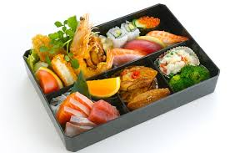
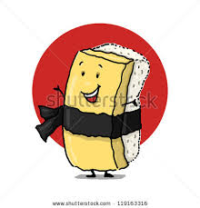
Drink Worksheet
The following worksheet is designed to help you discover the array of foods
flavours and styles of cooking in Japanese cuisine. Fill in the blanks with
Appropr appropriate answers.

The main points covered in the worksheet include:

Introduction
A. Japanese cuisine is known as (i) ____________________ or (ii) __________________ in Japanese. It is well-known for its emphasis on:
(i) using ingredients that are _______________.
(ii) using a wide _____________of ingredients.
(iii) taking care with the ______________ of each dish.
B. The staple food is ______________. This staple food is used in many ways. These include:
(i) (ii)
(iii) (iv)
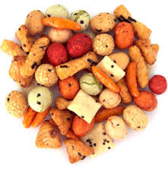
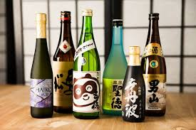
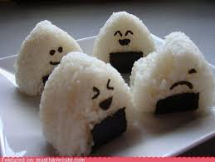

Food Fill out the table below with some examples of names, descriptions and pictures of Japanese food.
Name of Dish | Description | Picture
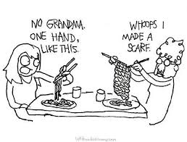

Eating Habits & Drink
C. Japanese people eat with chopsticks. 3 examples of good chopstick etiquette include:
1)
2)
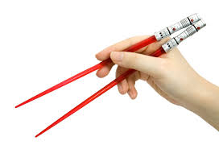
3)
2 important phrases said before and after each meal are:
_____________________ _______________________
Drink
Tea has played a pivotal role in Japanese culture and economy for a long time.
a. Japanese love drinking __________ tea which is called __________.
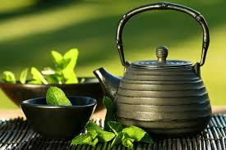
b. Japanese tea ceremony is a very stylised form of drinking tea. Provide 2
extra pieces of information about it here:
(i) ____________________________________________________
(ii) ___________________________________________________
c. 3 health benefits of green tea include:
1)
2)
3)
Finally……..
Japanese students rarely bring in sandwiches for their lunch like we do. What is the name of the lunch box they bring in, and give examples of what is inside.
_________________________________________
_________________________________________
_________________________________________

