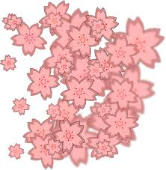
Team Name________

Q1 _____________________
Q2 _____________________
Q3 _____________________
Q4 _____________________
Q5 _____________________
Q6 _____________________
Q7 _____________________
Q8 _____________________
Q9 _____________________
Q10 _____________________
Q1 What does the title above say (in English)
Q2 What blossoms come into flower before the Cherry?
Q3 What is a dango?
Q4 Hana means flower. What does it also mean?
Q5 What is the Sakurazensen?
Q6 What is the name of the traditional Japanese instrument
Q7 What is the name of the type of musical scale often used for Japanese folk songs?
Q8 When does the Japanese school year start?
Q9 How long do the cherry blossoms last for?
Q10What colour kimono was I wearing in the photo?

