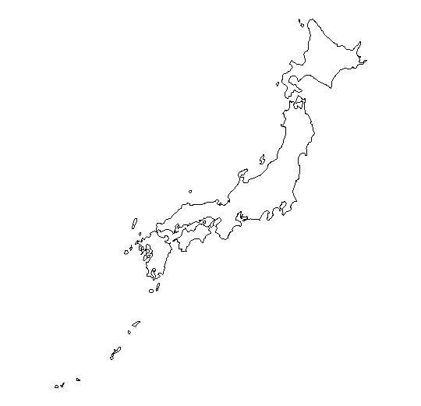 Team Name________
Q1 _____________________
Q2 _____________________
Q3 _____________________
Q4 _____________________
Q5 ____(write on map)_____
Q6 _____________________
Q7 _____________________
Q8 _____________________
Q9 _____________________
Q10 _____________________

Q1 What does the title above say (in English)
Q2 Name three neighbours of Japan
Q3 What is the capital city of Japan
Q4 What proportion of Japan is covered in mountains? Is it 40% or 80%
Q5 Locate the following on the blank map:
Tokyo, Osaka, Hokkaido, Okinawa, Fukushima
Q6 Guess what the weather might be like today in Tokyo?
Q7 Which of the follow animals is a native of Japan: Monkey, Tiger, Crocodile?
Q8 Which of the following is not a major agricultural product of Japan: Milk, Soyabeans, Bananas
Q9 Which of the following types of plants are not common in mainland Japan: Pine trees, Palm Trees, Bamboo
Q10 Mount Fuji is an active volcano. True or false?

