Travel and Tourism
EXPECTED TIME TAKEN
3 – 4 Hours
TOPIC OVERVIEW
In this topic, students will design a holiday to Japan to pitch to their classmates.

TASK DESCRIPTION
The aim of this task is for students to be able to research and design their own holiday to Japan.

1. Teacher presents project outline (attached), negotiates deadline and credit awards.

2. Students are then assigned (self-assign) teams of 4 and are given a destination in Japan.

3. Students must research flights, accommodation, travel options, maps,things to do for each season, meibutsu, omiyage and interesting facts about their chosen destination.

4. The class are given two classes in the computer room. One class is designed to help them research all the details for the project, and the second class is to design and practice their digital presentations.

5. Students can present using any digital tool of their choosing. In the past these have included PPT, Prezi and Powtoon.

6. At the end of the module, each group must present/pitch their holiday to the rest of the class for 8-15mins.

KEY SKILL(S)
- Managing myself, communicating, working with others, being creative, managing information and thinking. (JCKS)

LEARNING OUTCOMES
Students can research, design and budget for a holiday abroad, including flights, accommodation and itinerary.

Students can produce a high quality digital presentation for use in class, and develop their presentation skills.
Students can learn to work in a team.

RESOURCES
- Project outline

SCAFFOLDING ACTIVITIES
At the beginning of this module I make a short sample presentation about Shiga, where I lived in Japan, including some of the key components of the assigned project.
During the research aspect of the project I signpost obvious tourist attractions, or travel options, or help with the meaning of the kanji.

KEY LANGUAGE
Understanding of Kanji of place names, and their origins. Basic vocabulary for presenting. Regional food vocabulary.

CONTRIBUTOR
Therese Eagers

Japanese Tourism Project
You have been given a location in Japan for your final project. You must research and design a holiday to pitch to your class mates. You must present a poster format or a digital presentation. All the members of your team will receive the same credit. The presentations will take place in class during the final week of April (23rd – 26th) and the first week of May (1st- 4th ). Class time between now and then may be used for project work and preparation of presentation.

Points to be included
- Meibutsu and Omiyage– Research the famous food from the area and
what is the typical souvenir from the area
- Top four things to do – these must include something for every season. Please give as much detail as possible
- Map and travel itinerary – the area must be located on the map of Japan and your travel details must be included. Please research flights, ferries, trains etc.
- Origin of Kanji (placename meaning) and Interesting fact – this section speaks for itself. You must research the meaning of the kanji and find one interesting fact about the area!
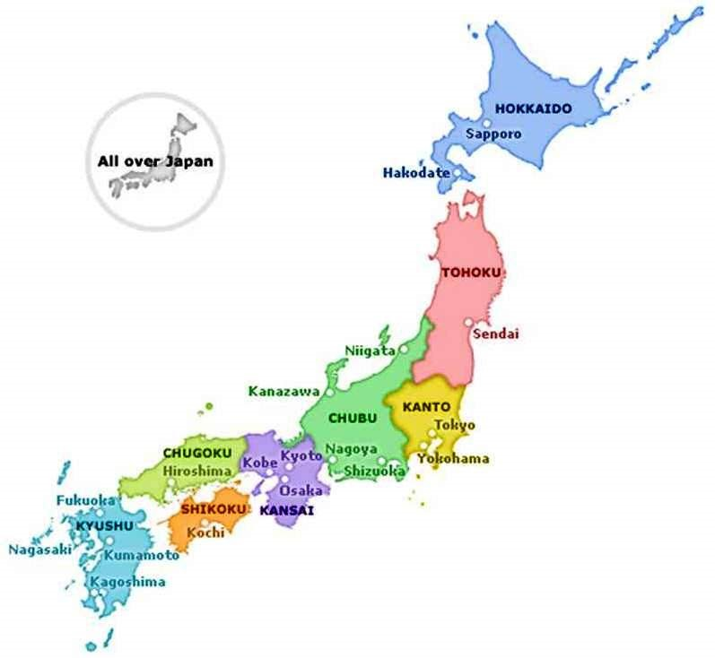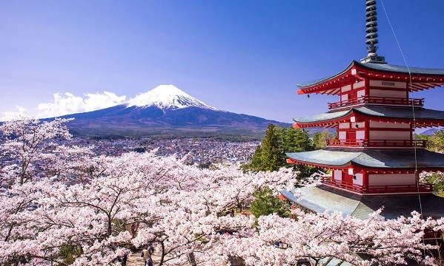

Ganbatte Kudasai

